## RDS Team Dynamics *Bi-Weekly Update*

**Assignment Goals / Deliverables:** Continuing the theme set with our first Team Dynamics assignment, we want you to get together with your team for a social activity either in-person or virtually (whichever you feel comfortable with). You can share a meal together, play a game, or something along those lines. This gathering should help you unwind a little, and allow you to reflect upon how your team has been performing over the last two weeks. As deliverables, we ask that you complete the following two tasks and upload them to the Canvas assignment:

* Take a photo / screenshot of your group at your gathering.
* Answer the questions below as a group.

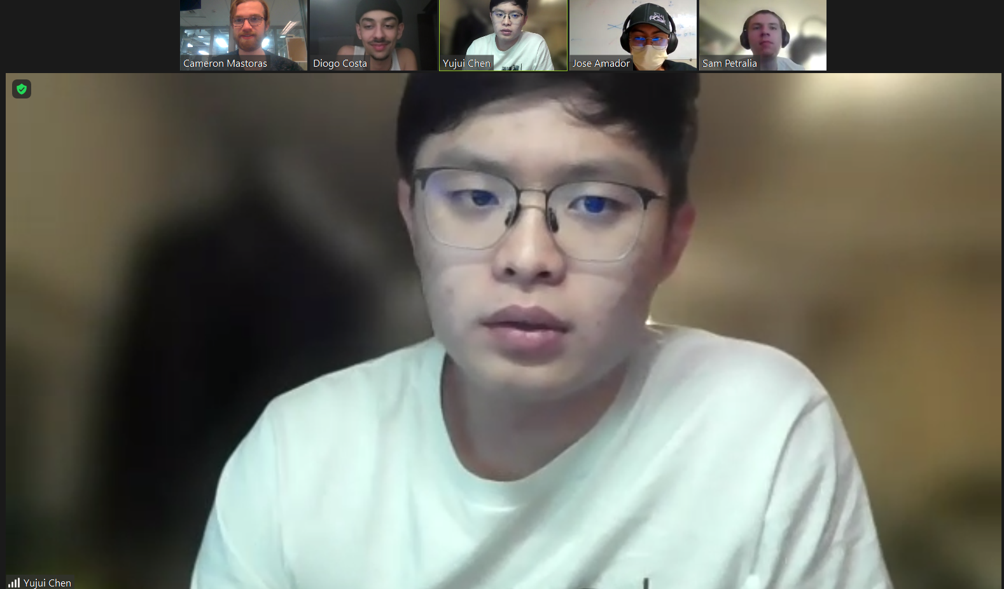

***Please be open and honest with yourselves and your group. There will be no penalties for the answers you provide in these bi-weekly updates, rather they should help you find areas for potential growth and help you recognize individual and team development.***

1. Have there been any conflicts or issues that have arisen within your team over the last two weeks? If so, what were they, and how were they resolved?

| Generally, we have been pretty conflict free over the past two weeks. It has been pretty heads down, get it done type work. We have been making good progress. |
| --- |

1. Are there any conflicts or issues within your team that are still outstanding that you would like to discuss during your next weekly meeting?

| As a team we would like to be a bit more responsive and committed. We really need to have everyone at every meeting in order to move forward as best as possible. |
| --- |

1. Are there any areas where you feel your team is excelling?

| Our meetings with professors have been really really productive, we are continuing to have discussions that generate great ideas and hit upon key concepts and technologies. We have been more prepared for meetings with professors, and we have been documenting meetings better. |
| --- |

1. Are there any areas where you feel your team needs improvement?

| As we self reflect, we think we need to start increasing the time commitment because we need to get more stuff done. From now on, implementing a soft rule of: each person makes some progress between each meeting, even if its a small thing. At each meeting, start by super quickly going around the horn and everyone says the thing they did. |
| --- |